

Luxor University
Faculty of Computers & Information

ــــــــــــــــــــــــــــــــــــــــــــــــــــــــــــــــــــــــــــــــــــــــــــــــــــــــــــــــــــــــــــــــــــــــــــــــــــــــــــــــــــــــــــــــــــــــــــــــــــــــــــــــــــــ



Agri-Pro

Agricultural Investment, Market and Management System

UNDER SUPERVISION
Dr. Bassem Abdelatty Eldeeb Eng. Abdelrahim Alsadiq

SUBMITTED BY
- Ali Mohsen - Maram Mahmoud
- Abo Elfadl Ramadan - Mayar Mohamed
- Mohamed Salah - Fatma Hassan

2026

Abstract

The Agricultural Investment Platform is a web-based digital solution designed to address major challenges in Egypt’s agricultural investment sector, including fragmented funding processes, limited transparency, weak stakeholder coordination, and the absence of structured project monitoring mechanisms. The platform provides a reliable and organized environment that supports agricultural investment activities and improves collaboration between farmers and investors throughout the investment lifecycle.

The system focuses primarily on investment operations by enabling farmers to present agricultural projects and investment opportunities in a clear and transparent manner. Investors can review project information, monitor implementation progress, evaluate expected outcomes, and make informed decisions based on verified and accessible data. The platform also supports investment tracking, financial reporting, documentation management, contract organization, and performance monitoring, contributing to improved accountability and stronger trust between all participating parties.

The platform mainly serves farmers and investors, while governmental organizations, agricultural institutions, and industry experts benefit from verified data and analytical insights that support planning and sustainable agricultural development initiatives. The system boundaries exclude logistics services, agricultural marketplaces, and fully automated farming operations. Developed using React.js and Node.js with Express.js, the platform represents a modern digital approach for organizing agricultural investment in EgyptTABLE OF CONTENTS

TABLE OF CONTENTS
ABSTRACT II
TABLE OF CONTENTS III
CHAPTER 1 SYSTEM OVERVIEW 3

1.1 | MOTIVATION | 4
1.2 | PROBLEM STATEMENT | 5
1.3 | OVERVIEW | 7
1.4 | OBJECTIVES AND SCOPE | 8
1.5 | TARGET AUDIENCE AND EXPECTED IMPACT | 8
CHAPTER | 2 RELATED WORKS | 11
2.1 | EXISTING SYSTEMS | 12
2.2 | COMPARISON & LIMITATIONS | 15
2.3 | JUSTIFICATION FOR THE PROPOSED SYSTEM | 18
CHAPTER | 3 SYSTEM REQUIREMENTS & TECHNIQUE | 21
3.1 | SYSTEM REQUIREMENTS | 22
3.1.1 | FUNCTIONAL REQUIREMENTS | 22
3.1.2 | NON-FUNCTIONAL REQUIREMENTS | 24
3.2 | TECHNIQUES AND TOOLS | 25
CHAPTER | 4 PROPOSED SYSTEM & METHODOLOGY | 28
4.1 | SYSTEM USE CASE DIAGRAM | 29
4.2 | USE CASE DESCRIPTION (USE CASE SCENARIO) | 32
4.3 | SYSTEM ARCHITECTURE | 32
4.4 | DATAFLOW DIAGRAMS | 38
4.4.1 | CONTEXT DIAGRAM (LEVEL 0) | 39
4.4.2 | DATAFLOW DIAGRAM (LEVEL 1) | 41
4.5 | ACTIVITY DIAGRAM | 45
4.6 | SEQUENCE DIAGRAMS | 46
4.7 | ER DIAGRAM | 47
CHAPTER | 5 CONCLUSIONS & FUTURE WORK | 48
5.1 | CONCLUSIONS | 49
5.2 | FUTURE WORK | 50
5.3 | REFERENCES | 53

CHAPTER 1

SYSTEM OVERVIEW
  - Motivation
The agricultural sector represents a fundamental component of the Egyptian economy, contributing significantly to national income and providing employment opportunities for a large segment of the population, particularly within rural communities. In addition to its economic contribution, the sector plays a critical role in supporting food security and promoting sustainable development. Despite its strategic importance, agricultural investment in Egypt remains relatively limited and lacks the level of organization and transparency required to attract wider investor participation.

The Egyptian agricultural sector possesses substantial investment potential; however, several challenges continue to hinder effective investment activities. These challenges include fragmented investment processes, insufficient access to reliable agricultural data, limited transparency, and weak communication between farmers and potential investors. As a result, many agricultural projects face difficulties in securing funding, while investors remain hesitant to participate due to uncertainty and the absence of structured monitoring mechanisms.

Recent regional and global trends indicate significant growth opportunities within the agricultural sector, particularly in emerging markets across Africa and the Middle East. This highlights the need for modern digital solutions capable of improving investment efficiency and supporting informed decision-making within agricultural projects.

The motivation behind this project is to develop a digital agricultural investment platform tailored to the Egyptian environment, aiming to create a transparent and organized framework that connects farmers with investors through reliable and verified information. The platform seeks to improve investment accessibility, increase trust between stakeholders, support sustainable agricultural development, and contribute to enhancing the overall efficiency and competitiveness of the agricultural sector in Egypt..

  - PROBLEM STATEMENT
CURRENT SITUATION
Agricultural investment in Egypt continues to face several structural and technological challenges that limit its efficiency and sustainability. Current investment activities rely heavily on informal communication methods, fragmented documentation, and manual administrative procedures. In many cases, there is no unified digital environment that enables effective interaction between farmers and investors or supports transparent monitoring throughout the investment lifecycle. As a result, project evaluation, financial follow-up, and investment monitoring processes remain inefficient and vulnerable to uncertainty and mismanagement.
FARMER CHALLENGE
Farmers encounter multiple difficulties that reduce their ability to attract investment opportunities and manage agricultural projects effectively, including:
• Lack of digital documentation for agricultural activities and project records
• Difficulty accessing reliable investment opportunities and financial support
• Weak communication channels with investors and funding entities
• Limited ability to present agricultural projects professionally
• Absence of transparent mechanisms for reporting project progress and operational performance
• Limited access to tools that support credibility, accountability, and risk reduction

INVESTOR CHALLENGES
Investors also face significant obstacles that discourage participation in agricultural projects, such as:
• Limited availability of reliable data regarding agricultural projects and land productivity
• Lack of transparency concerning expected returns, costs, and investment risks
• Absence of trusted digital platforms for evaluating agricultural investment opportunities
• Difficulty monitoring project implementation and identifying potential risks at early stages
• High levels of uncertainty caused by insufficient documentation and weak reporting systems
• Limited access to verified information about farmers and project feasibility

OPERATIONAL AND SYSTEMIC CHALLENGES
The agricultural investment sector also suffers from broader operational limitations, including:

• Absence of standardized digital processes for managing agricultural investments
• Weak monitoring and oversight mechanisms, increasing the risk of disputes and inefficiencies
• Dependence on manual documentation and financial procedures, leading to delays and inaccuracies
• Lack of integrated systems that support transparency and organized communication between stakeholders

These challenges create a significant gap between farmers and investors, limiting the growth potential of agricultural investment despite the sector’s economic importance and available opportunities. Therefore, there is a growing need for a digital agricultural investment platform that improves transparency, facilitates communication, supports informed investment decisions, and enhances the efficiency and sustainability of agricultural investment activities in Egypt.

  - OVERVIEW
The Agricultural Investment Platform is a web-based digital ecosystem designed to enhance agricultural investment activities in Egypt by establishing a structured and transparent environment that connects farmers and investors. The platform focuses on improving access to agricultural investment opportunities and supporting data-driven decision-making through a unified digital framework. .

System Architecture
The platform is primarily composed of a dedicated Investment System that serves as the core component of the solution. This system enables farmers to register and present comprehensive details about their agricultural projects, including land information, crop types, cultivated area, production estimates, operational costs, and cultivation schedules. Investors are able to explore available agricultural opportunities, analyze project data, and evaluate investment feasibility based on structured and reliable information.
The system supports the full investment cycle, beginning with project registration and investor participation, and continuing through funding allocation and project evaluation. It ensures transparency in investment operations by organizing agricultural data in a standardized format, allowing stakeholders to make informed and well-structured investment decisions.

Core Capabilities
The platform incorporates essential technological capabilities that enhance investment efficiency and reliability, including:
- Structured digital documentation of agricultural projects and investment data
- Transparent presentation of project details to support informed investment decisions
- Standardized mechanisms for managing investment agreements and financial expectations
- Continuous tracking of investment activities to ensure accountability and clarity
- Data-based reporting that supports risk assessment and investment evaluation

System Integration
The platform is designed to function as an integrated investment environment where farmers and investors interact within a unified digital system. Farmers utilize the platform to present their agricultural projects in a structured manner, while investors use it to identify and evaluate suitable investment opportunities. The system supports a continuous investment cycle that promotes trust, improves transparency, and encourages sustainable agricultural investment practices.
The primary objective of the platform is to modernize agricultural investment in Egypt by creating a reliable digital infrastructure that enhances transparency, improves access to investment opportunities, and supports efficient and informed decision-making within the agricultural sector.

  - OBJECTIVES AND SCOPE

Core Objectives
The platform is designed to achieve the following objectives to improve agricultural investment in Egypt:
- Develop a digital agricultural investment platform that connects farmers and investors within a transparent and secure environment.
- Enable farmers to present structured agricultural project data relevant to investment decisions, such as production estimates, costs, and risks.
- Provide a reliable agricultural investment database including land information, crop data, and productivity indicators.
- Support investors in making informed decisions using verified data and analytical insights.
- Enhance transparency in agricultural investment by standardizing how project information is shared between stakeholders.
- Reduce information asymmetry between farmers and investors to improve investment efficiency.
- Facilitate access to agricultural investment opportunities through structured and comparable project profiles.
- Promote data-driven investment practices to increase trust and reduce uncertainty in the agricultural sector.

System Scope

In-Scope Features
Investment System:
- Investor interface for browsing and evaluating agricultural investment opportunities
- Project profiling tools for presenting structured agricultural investment data
- Analytical summaries for costs, expected returns, and risk indicators
- Reporting system providing standardized investment information for decision support
Farmer Side:
- Submission of agricultural project data for investment purposes
- Structured display of key project indicators (land, crops, costs, outputs)
- Data transparency tools to improve investor confidence
- Communication channel between farmers and investors for inquiries and negotiation
Platform-Wide Features:
- Centralized investment data repository
- Data analytics for investment insights and trends
- Secure authentication and role-based access control
- Multi-user system supporting farmers and investors

Out-of-Scope Features
The system explicitly excludes:
- Agricultural operations management or farm execution tracking
- Mobile application development (initial release)
- Logistics, transportation, or product delivery services
- Storage, warehousing, or supply chain operations
- Automated farming systems (irrigation, machinery control, etc.)
- Insurance services for agriculture or investments
- Stock market or financial trading integration
- Legal enforcement of contracts beyond documentation support

Target Audience and Expected Impact

Target Audience
Primary Users:
- Farmers presenting investment opportunities
- Investors seeking agricultural investment projects
- Agricultural enterprises looking for structured funding opportunities
Secondary Users:
- Government and policy institutions
- Agricultural and economic research bodies
- Financial and agricultural consultants

Expected Impact

Economic Impact
- Improve agricultural investment flow and capital access
- Reduce investment uncertainty through structured data
- Increase efficiency of matching farmers with investors

Social Impact
- Strengthen trust between stakeholders
- Support rural economic development
- Encourage digital adoption in agriculture

Technological Impact
- Enable structured agricultural investment data systems
- Support data-driven investment decision-making
- Contribute to digital transformation in the agricultural sector

CHAPTER 2

RELATED WORKS
2.1 EXISTING SYSTEMS
The agricultural technology landscape has witnessed significant growth in recent years, with various platforms attempting to address different aspects of agricultural challenges. This section analyzes existing solutions in three main categories: agricultural investment platforms, farm management systems, and agricultural marketplaces.
2.1.1 Agricultural Investment Platforms
FarmTogether (United States)
- Description: A crowdfunding platform that allows investors to invest in farmland across the United States
- Features: Fractional ownership of farmland, professional farm management, transparent reporting
- Target Market: Primarily U.S. investors and farmland
- Strengths: Established legal framework, professional management, detailed financial reporting
- Limitations: Limited to farmland ownership rather than crop-specific investments, no direct farmer participation, U.S.-focused with limited international reach

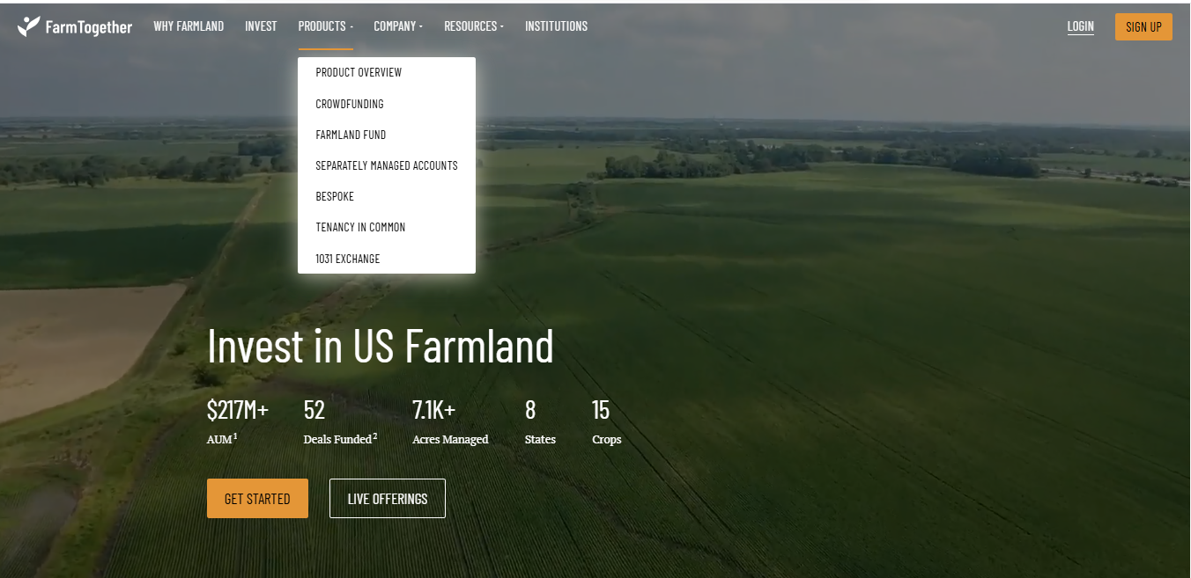

AcreTrader (United States)
- Description: An online farmland investing platform offering shares in agricultural properties
- Features: Due diligence reports, land management services, annual reporting
- Target Market: Accredited investors in the U.S.
- Strengths: Rigorous vetting process, professional farm operations
- Limitations: High minimum investment thresholds, focuses on land assets rather than operational farming, excludes small-scale farmers

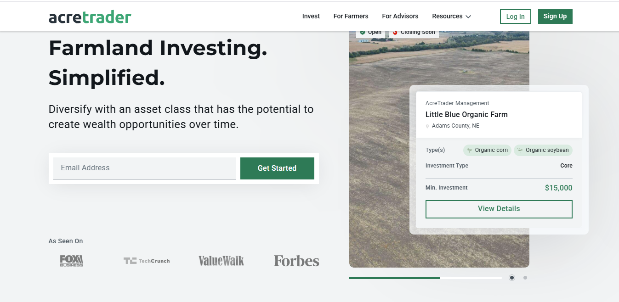

2.1.2 Regional Arab Platforms
Mazra3ti (Egypt)
- Description: An agricultural e-commerce platform for selling agricultural products
- Features: Online ordering, delivery services
- Target Market: Egyptian consumers and farmers
- Strengths: Local market understanding, Arabic interface
- Limitations: Traditional e-commerce model, no investment component, limited to specific regions, basic technology

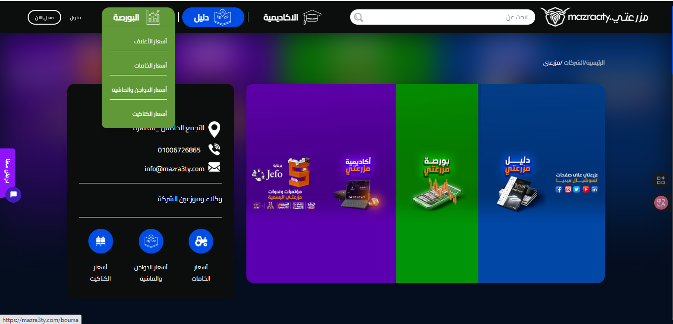

2.2 COMPARISON & LIMITATIONS
2.2.1 Comparative Analysis
The following table provides a comprehensive comparison of existing systems against key features required for a holistic agricultural ecosystem:

Feature/Capability | Investment Platforms | Management Systems | Marketplaces | Arab Platforms | Proposed System
Farmer Investment Access | Limited | ✗ | ✗ | ✗ | ✓
Direct Farmer-Investor Connection | Partial | ✗ | ✗ | ✗ | ✓
AI-Powered Analytics | Basic | Partial | ✗ | ✗ | ✓
Real-Time Project Monitoring | Limited | ✓ | ✗ | ✗ | ✓
Smart Contracts | ✗ | ✗ | ✗ | ✗ | ✓
Direct Market Access | ✗ | Partial | ✓ | Partial | ✓
Transparent Profit Sharing | Partial | ✗ | ✗ | ✗ | ✓
Multi-Stakeholder Platform | ✗ | ✗ | Partial | ✗ | ✓
Arabic Language Support | ✗ | ✗ | ✗ | Partial | ✓
Regional Focus (Arab World) | ✗ | ✗ | ✗ | Limited | ✓
Fractional Investment | ✓ | ✗ | ✗ | ✗ | ✓
Integrated Ecosystem | ✗ | ✗ | ✗ | ✗ | ✓
Low Entry Barriers | ✗ | Partial | ✓ | Partial | ✓
Risk Assessment Tools | Basic | Partial | ✗ | ✗ | ✓
Post-Harvest Sales Support | ✗ | ✗ | ✓ | Partial | ✓

2.2.2 Critical Limitations of Existing Solutions
Geographic and Cultural Limitations
- Western-Centric Design: Most advanced platforms (FarmTogether, AcreTrader, FarmLogs) are designed for Western agricultural contexts and regulatory frameworks
- Language Barriers: Minimal Arabic language support across major platforms
- Cultural Misalignment: Investment models don't align with Arab agricultural practices and land ownership structures
- Limited Regional Coverage: Existing Arab platforms have limited geographic reach and scalability
Functional Limitations
- Fragmented Solutions: No single platform integrates investment, management, and marketplace functions
- Limited Farmer Access: Investment platforms often exclude small-scale farmers or require significant minimum investments
- Lack of Transparency: Insufficient real-time monitoring and reporting for investors
- No Smart Automation: Manual processes for contract execution and profit distribution
- Weak AI Integration: Limited use of artificial intelligence for decision support and risk assessment
Accessibility Limitations
- High Entry Costs: Many platforms require substantial minimum investments or subscription fees
- Complex Technology: Sophisticated systems too complex for farmers with limited digital literacy
- Infrastructure Requirements: Heavy reliance on advanced infrastructure (satellite, IoT sensors) not available in all regions
- Accredited Investor Requirements: Some platforms restricted to accredited or institutional investors

Operational Limitations
- Intermediary Models: Many marketplaces act as intermediaries rather than true peer-to-peer platforms
- Limited Post-Investment Support: Minimal support for harvest, sales, and reinvestment cycles
- Weak Verification Systems: Insufficient user verification and project validation mechanisms
- No End-to-End Solution: Farmers must use multiple disconnected platforms for different needs
Trust and Security Limitations
- Limited Fraud Prevention: Weak mechanisms to prevent fraud or misrepresentation
- Opaque Financial Flows: Unclear profit calculation and distribution processes
- No Dispute Resolution: Minimal structured approaches to handling disagreements
- Data Privacy Concerns: Inadequate protection of sensitive agricultural and financial data

2.3 JUSTIFICATION FOR THE PROPOSED SYSTEM
2.3.1 Addressing the Market Gap
The proposed Agricultural Investment and Management Platform addresses critical gaps in the existing ecosystem:
1. Integrated Multi-Stakeholder Approach
Unlike existing solutions that serve single stakeholder groups, our platform creates a complete ecosystem connecting farmers, investors, and buyers. This integration eliminates the need for multiple disconnected tools and creates synergies across the agricultural value chain.
Justification: Farmers need funding (investment system), operational management (management system), and market access (marketplace). No existing platform provides all three, forcing stakeholders to navigate fragmented solutions with inconsistent data and processes.
2. Regional Focus on Arab Agricultural Context
The platform is specifically designed for the Arab world's unique agricultural landscape, including
- Arabic-first interface and content
- Alignment with Islamic finance principles and regional investment preferences
- Understanding of local crop types, farming practices, and seasonal cycles
- Compliance with regional regulations and agricultural policies
- Cultural sensitivity in stakeholder interactions
Justification: Western-designed platforms fail to address Arab-specific needs, while existing regional platforms lack the technological sophistication and comprehensive feature sets. The Arab agricultural market represents $1 trillion in potential by 2030, requiring purpose-built solutions.
3. AI-Driven Intelligence and Decision Support
Our advanced AI analytics engine goes beyond basic data collection to provide:
- Predictive analytics for crop yields and market prices
- Risk assessment models specific to regional agricultural conditions
- Personalized investment recommendations based on investor preferences and project characteristics
- Automated anomaly detection and early warning systems
- Performance benchmarking against similar projects and historical data
Justification: Existing platforms offer limited AI capabilities, relying primarily on manual analysis. The complexity and variability of agricultural investments demand intelligent automation to reduce risks and improve decision-making quality.
4. Inclusive and Accessible Design
The platform democratizes agricultural investment through:
- Low minimum investment thresholds enabling fractional ownership
- Simple, intuitive interfaces suitable for users with varying digital literacy
- Mobile-responsive design for access in rural areas
- Support for various payment methods popular in the region
- Progressive disclosure of complexity (simple for beginners, powerful for experts)
Justification: Existing investment platforms exclude small investors and smallholder farmers through high barriers to entry. Our inclusive design unlocks the vast potential of micro-investments and small-scale farming.
5. Complete Value Chain Coverage
Our integrated approach covers the entire agricultural cycle:
- Pre-Season: Project planning and investment matching
- During Season: Real-time monitoring and management
- Post-Harvest: Direct market access and sales facilitation
- Settlement: Automated profit calculation and distribution
- Reinvestment: Encouraging continuous participation
Justification: Fragmented solutions create inefficiencies and data gaps. End-to-end coverage ensures seamless transitions between phases and accumulation of valuable longitudinal data.

2.3.2 Competitive Advantages
Our platform offers distinct competitive advantages:
- First-Mover Advantage in Arab Markets: First comprehensive agri-tech platform specifically designed for the Arab world
- Network Effects: Three-sided marketplace creates powerful network effects as each stakeholder group attracts others
- Data Accumulation: Continuous data collection builds valuable datasets for improving AI models and understanding regional agriculture
- Trust Infrastructure: Verification systems and smart contracts create a foundation of trust that's difficult to replicate
- Scalability: Cloud-based architecture and modular design enable rapid expansion across countries and crop types
- Strategic Partnerships: Opportunities to partner with governments, agricultural organizations, and financial institutions

CHAPTER 3

SYSTEM REQUIREMENTS
&

TECHNIQUE
  - SYSTEM REQUIREMENTS
    - FUNCTIONAL REQUIREMENTS

ID | Functional Requirement | Description (Priority Integrated, Clear & Testable)
FR1 | User Registration | The system must enable farmers and investors to register with personal details, farm information, investment interests, and payment preferences. Registration must be secure and verifiable.
FR2 | User Verification | The system must verify identities of farmers and investors to prevent fraud using secure authentication methods. Verification must be reliable under normal and peak load conditions.
FR3 | Project Submission | Farmers must submit agricultural project proposals including crop type, estimated cost, expected profit, duration, and potential risks using a structured submission form. The system should provide clear guidance to minimize errors.
FR4 | Project Approval | The system must review and approve submitted projects and make them available as "Investable Projects" in the dashboard. Approval processing should be timely and auditable.
FR5 | Project Display | Approved projects must be displayed to investors with full details, images, and expected financial outcomes in a clear and accessible dashboard. Display should load efficiently for multiple users.
FR6 | Investment Management | Investors must be able to fund projects fully or partially, with the system recording agreements and generating smart contracts specifying profit-sharing, responsibilities, and loss allocation. Investment processes should be secure and auditable.
FR7 | Payment Handling | The system must facilitate secure electronic payments or escrow account transfers from investors to farmers with encryption and confirmation tracking. Payment processing should be reliable and timely.
FR8 | Farming Execution Tracking | Farmers should update weekly reports including images, videos, and crop status.
FR9 | Risk Notification | The system must notify investors immediately in case of issues such as crop disease or natural risks. Notifications should be accurate, timely, and traceable.
FR10 | Harvest Reporting | Farmers should submit actual production and profit reports at harvest, which are verified by the system for accuracy. Reporting should be structured and easy to validate.
FR11 | Profit and Loss Distribution | The system must automatically calculate and distribute profits according to contract terms or assign responsibility for losses. Calculations should be auditable and accurate.
FR12 | Performance Evaluation | Upon project completion, the system could allow rating of farmers and investors to improve transparency and credibility. Ratings should be structured and visible to relevant stakeholders.
FR13 | Reinvestment Option | Investors could reinvest profits directly into new projects through the dashboard. The system should facilitate easy selection and confirmation of reinvestment.

    - NON-FUNCTIONAL REQUIREMENTS

Category | Requirement | Description
Performance | System Response | Each operation (such as reservation or loading a guide) should execute within 9 seconds.
Usability | Simple Interface | Designed for farmers with minimal technical knowledge: clear icons and Arabic / English text.
Reliability | Error Recovery | The subsystem should handle input errors gracefully and log failures for review.
Security | Data Protection | Sensitive information such as user identity and contact info must be encrypted.
Scalability | Integration Ready | Should integrate smoothly with the Investment and Store subsystems under the main platform.
Maintainability | Modular Design | Built as a self-contained module that can be maintained independently.
Availability | System Uptime | The subsystem should remain available 98% of the time for uninterrupted access.
Accessibility | Responsive Design | Compatible with both desktop and mobile devices, supporting right-to-left Arabic layout.
Portability | Shared Architecture | Built using the same technologies as other main system components for consistency.

  - TECHNIQUES AND TOOLS


Frontend Development

React.js was used to develop the frontend of the Agri-Pro Platform due to its
component-based architecture and ability to build scalable and responsive user interfaces.
Reusable components were implemented for dashboards, project cards, investment summaries,
and product listings. Role-based rendering was applied to provide customized views for
Farmers, Investors, Buyers, and Admins.


Tailwind CSS was used for styling due to its utility-first approach, enabling rapid UI
development and consistent design across the platform. Responsive layouts were implemented
using predefined breakpoints to support Desktop, Tablet, and Mobile devices.



Vite and npm were used as build and package management tools to ensure fast development,
efficient dependency management, and optimized production builds.


Backend Development


C# with ASP.NET Core was selected for backend development due to its high performance,
security, and scalability. The backend follows a layered architecture separating controllers,
services, and data access.
RESTful APIs were implemented to enable communication between the frontend and backend.
JWT-based authentication and Role-Based Access Control (RBAC) were applied to secure system
access and manage user permissions.

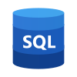

Database and Data Management


Microsoft SQL Server was used as the primary relational database to store structured data
related to users, projects, investments, farms, and marketplace products. Database
transactions and indexing were applied to ensure data consistency and improve performance.
An Analytics Database was used to store reporting and performance metrics, while
Azure Blob Storage was utilized for storing images, reports, and digital contracts.

Security, Infrastructure, and Integrations




Security was ensured using SSL/TLS encryption, JWT authentication, and data
encryption. Infrastructure tools such as load balancing, automated backups, and
monitoring services were implemented to enhance reliability and availability.
External integrations include Weather APIs for agricultural insights and Email/SMS
services for system notifications. Git and GitHub were used for version control,
collaboration, and code backup.

CHAPTER 4

PROPOSED SYSTEM & METHODOLOGY

  - SYSTEM USE CASE DIAGRAM

Farmer & Expert Team:

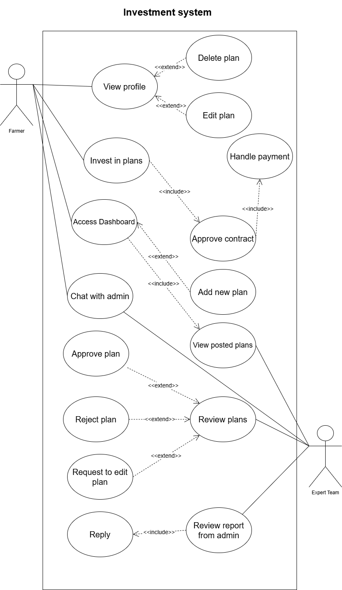

Investor:

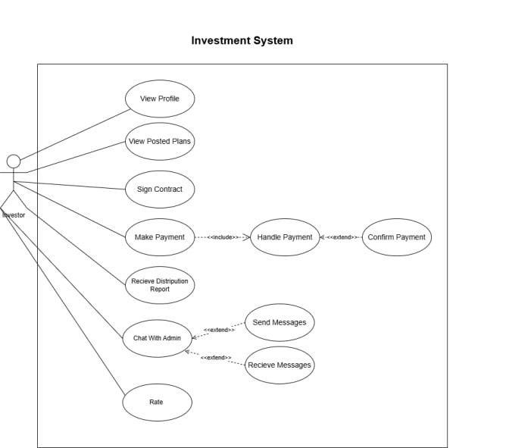

Admin:

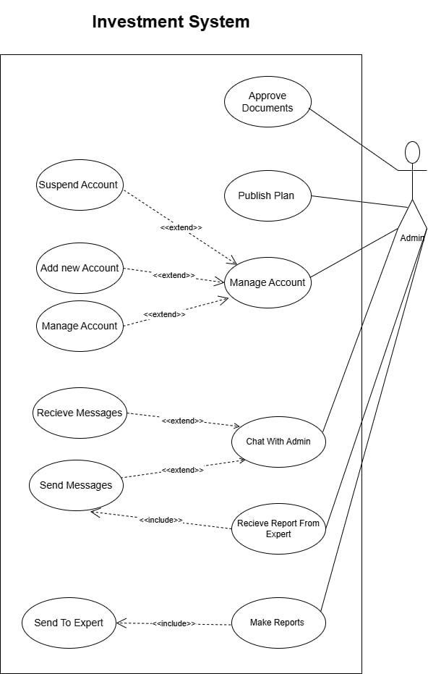

  - USE CASE DESCRIPTION (USE CASE SCENARIO)
For Investment Part:
Farmer:
1 – View Profile
Use Case ID | UC-F01
Use Case Name | View Profile
Primary Actor | Farmer
Secondary Actor | System
Pre-Conditions | Farmer is logged into the system.
Main Flow | 1. Farmer opens profile page.  2. System retrieves personal, farm and account data.  3. System displays profile information.
Alternative Flow | Farmer edits profile data and saves changes.
Exception Flow | System fails to retrieve profile data.
Post-Conditions | Profile information is viewed or updated.

2– Add New Investment Plan
Use Case ID | UC-F02
Use Case Name | Add New Investment Plan
Primary Actor | Farmer
Secondary Actor | Expert Team
Pre-Conditions | Farmer is logged in.
Main Flow | 1. Farmer selects Add New Plan.  2. System displays form.  3. Farmer enters plan details.  4. Farmer submits plan.  5. System validates data.  6. Plan saved as Pending Review.  7. Expert Team notified.
Alternative Flow | System asks farmer to correct invalid or missing data.
Exception Flow | System error while saving plan.
Post-Conditions | Plan stored and awaiting expert review.

3– Edit Plan
Use Case ID | UC-F03
Use Case Name | Edit Plan
Primary Actor | Farmer
Secondary Actor | Expert Team
Pre-Conditions | Farmer logged in and plan exists.
Main Flow | 1. Farmer selects plan.  2. Farmer edits details.  3. System validates updates.  4. System saves changes.
Alternative Flow | Expert Team requests changes after review.
Exception Flow | System update failure.
Post-Conditions | Plan updated successfully.

4– Delete Plan
Use Case ID | UC-F04
Use Case Name | Delete Plan
Primary Actor | Farmer
Secondary Actor | System
Pre-Conditions | Plan not yet approved.
Main Flow | 1. Farmer selects delete plan.  2. System asks confirmation.  3. Farmer confirms.  4. System deletes plan.
Alternative Flow | Farmer cancels deletion.
Exception Flow | Deletion process fails.
Post-Conditions | Plan removed from system.

5– View Posted Plans
Use Case ID | UC-F05
Use Case Name | View Posted Plans
Primary Actor | Farmer
Secondary Actor | Expert Team
Pre-Conditions | Farmer logged in.
Main Flow | 1. Farmer selects View Plans.  2. System displays farmer approved plans.  3. Farmer views plan details.
Alternative Flow | No plans available.
Exception Flow | Plans cannot be loaded.
Post-Conditions | Farmer reviews available plans.

6– Chat with Admin
Use Case ID | UC-F06
Use Case Name | Chat with Admin
Primary Actor | Farmer
Secondary Actor | Admin
Pre-Conditions | Both logged in.
Main Flow | 1. Farmer opens chat.  2. Farmer sends message.  3. Admin replies.  4. Conversation saved.
Alternative Flow | Admin offline, message queued.
Exception Flow | Chat service unavailable.
Post-Conditions | Messages exchanged.

Expert Team

1 – Review Plans
Use Case ID | UC-E01
Use Case Name | Review Plans
Primary Actor | Expert Team
Secondary Actor | Farmer
Pre-Conditions | Pending plans exist.
Main Flow | 1. Expert opens review list.  2. Selects plan.  3. Reviews details.  4. Makes decision.
Alternative Flow | Request edit from farmer.
Exception Flow | Plan data unavailable.
Post-Conditions | Plan status updated.

2 – Approve Plan
Use Case ID | UC-E02
Use Case Name | Approve Plan
Primary Actor | Expert Team
Secondary Actor | Farmer
Pre-Conditions | Plan pending review.
Main Flow | 1. Expert approves plan.  2. System marks as approved.
Alternative Flow | None.
Exception Flow | Approval fails.
Post-Conditions | Plan ready for publishing.

3 – Reject Plan
Use Case ID | UC-E03
Use Case Name | Reject Plan
Primary Actor | Expert Team
Secondary Actor | Farmer
Pre-Conditions | Plan pending.
Main Flow | 1. Expert rejects plan.  2. System updates status.
Alternative Flow | None.
Exception Flow | Rejection fails.
Post-Conditions | Plan rejected.

4 – Reply to Admin Report
Use Case ID | UC-E04
Use Case Name | Reply to Admin Report
Primary Actor | Expert Team
Secondary Actor | Admin
Pre-Conditions | Report received.
Main Flow | 1. Expert reviews report.  2. Sends feedback.  3. System delivers response.
Alternative Flow | Request clarification.
Exception Flow | Message delivery fails.
Post-Conditions | Reply sent.

Admin:

1 – Manage Accounts
Use Case ID | UC-A01
Use Case Name | Manage Accounts
Primary Actor | Admin
Secondary Actor | System
Pre-Conditions | Admin logged in.
Main Flow | 1. Admin views accounts.  2. Admin adds, updates or suspends account.  3. System saves changes.
Alternative Flow | Admin cancels action.
Exception Flow | Saving changes fails.
Post-Conditions | Accounts updated.

2 – Approve Documents
Use Case ID | UC-A02
Use Case Name | Approve Documents
Primary Actor | Admin
Secondary Actor | System
Pre-Conditions | Documents submitted.
Main Flow | 1. Admin reviews documents.  2. Admin approves documents.
Alternative Flow | Reject documents.
Exception Flow | Approval fails.
Post-Conditions | Documents approved.

3 – Publish Plan
Use Case ID | UC-A03
Use Case Name | Publish Plan
Primary Actor | Admin
Secondary Actor | System
Pre-Conditions | Plan approved by experts.
Main Flow | 1. Admin publishes plan.  2. System makes plan visible.
Alternative Flow | Admin delays publishing.
Exception Flow | Publishing fails.
Post-Conditions | Plan published.

4 – Make Reports
Use Case ID | UC-A04
Use Case Name | Make Reports
Primary Actor | Admin
Secondary Actor | Expert Team
Pre-Conditions | Admin logged in.
Main Flow | 1. Admin creates report.  2. System saves report.  3. Admin sends report.
Alternative Flow | Edit report before sending.
Exception Flow | Report save fails.
Post-Conditions | Report sent.

Investor:

1 – Sign Contract
Use Case ID | UC-I01
Use Case Name | Sign Contract
Primary Actor | Investor
Secondary Actor | System
Pre-Conditions | Investor logged in.
Main Flow | 1. Investor reviews contract.  2. Investor signs digitally.  3. System records signature.
Alternative Flow | Investor declines contract.
Exception Flow | Signing fails.
Post-Conditions | Contract signed.

2 – Make Payment
Use Case ID | UC-I02
Use Case Name | Make Payment
Primary Actor | Investor
Secondary Actor | Payment Gateway
Pre-Conditions | Contract signed.
Main Flow | 1. Investor enters payment info.  2. Gateway processes payment.  3. System receives confirmation.
Alternative Flow | Payment rejected.
Exception Flow | Gateway unavailable.
Post-Conditions | Payment completed.

3 – Receive Distribution Report
Use Case ID | UC-I03
Use Case Name | Receive Distribution Report
Primary Actor | Investor
Secondary Actor | Admin
Pre-Conditions | Investment completed.
Main Flow | 1. System sends report.  2. Investor reviews report.
Alternative Flow | None.
Exception Flow | Report unavailable.
Post-Conditions | Report received.

4 – Rate Investment
Use Case ID | UC-I04
Use Case Name | Rate Investment
Primary Actor | Investor
Secondary Actor | System
Pre-Conditions | Investment completed.
Main Flow | 1. Investor submits rating.  2. System saves rating.
Alternative Flow | Investor skips rating.
Exception Flow | Rating save fails.
Post-Conditions | Rating recorded.

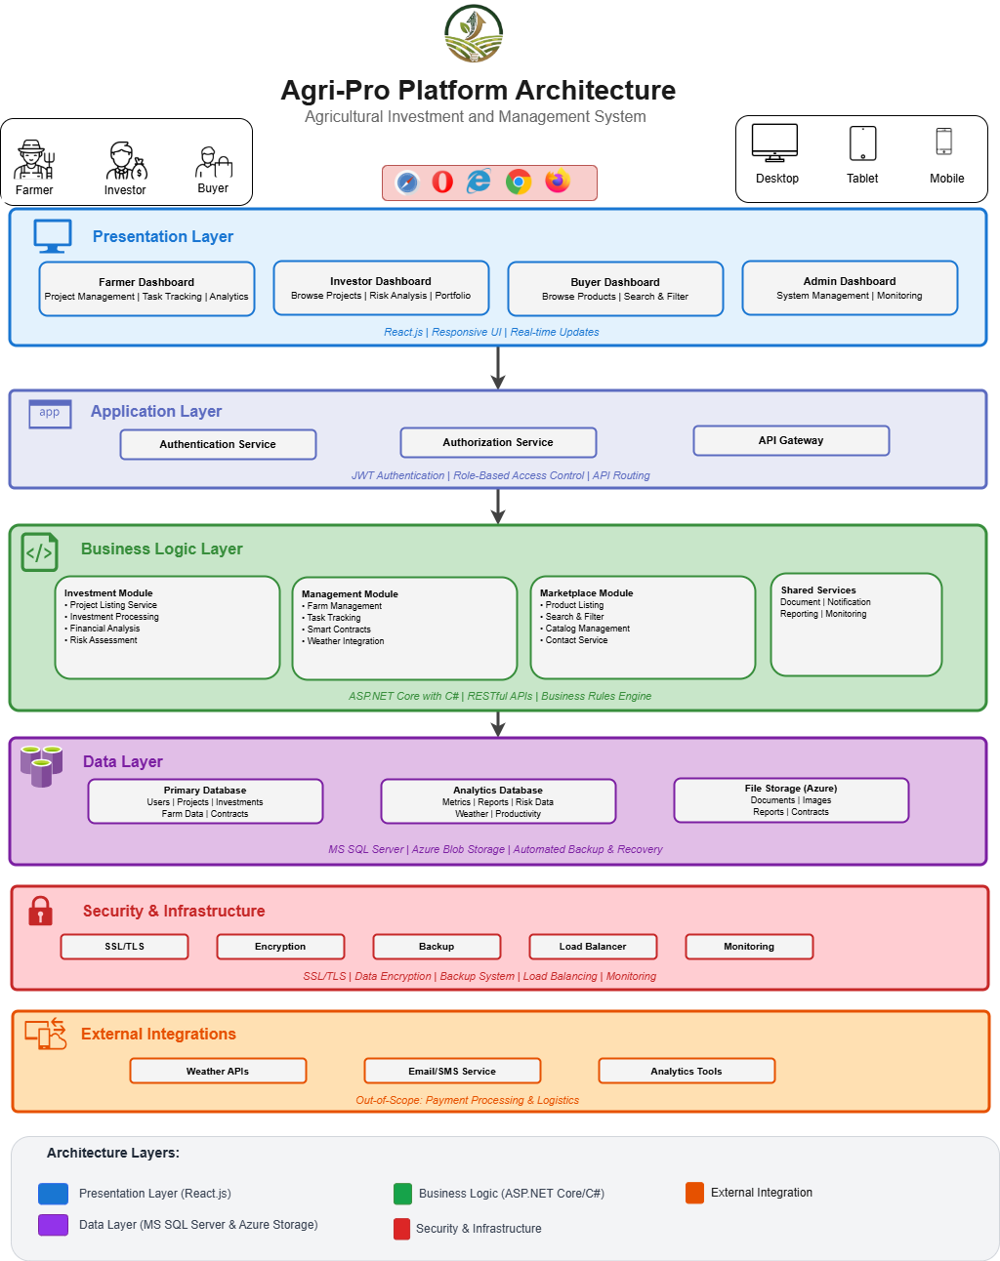
  - SYSTEM ARCHITECTURE

  - DATAFLOW DIAGRAMS
    - CONTEXT DIAGRAM (LEVEL 0)

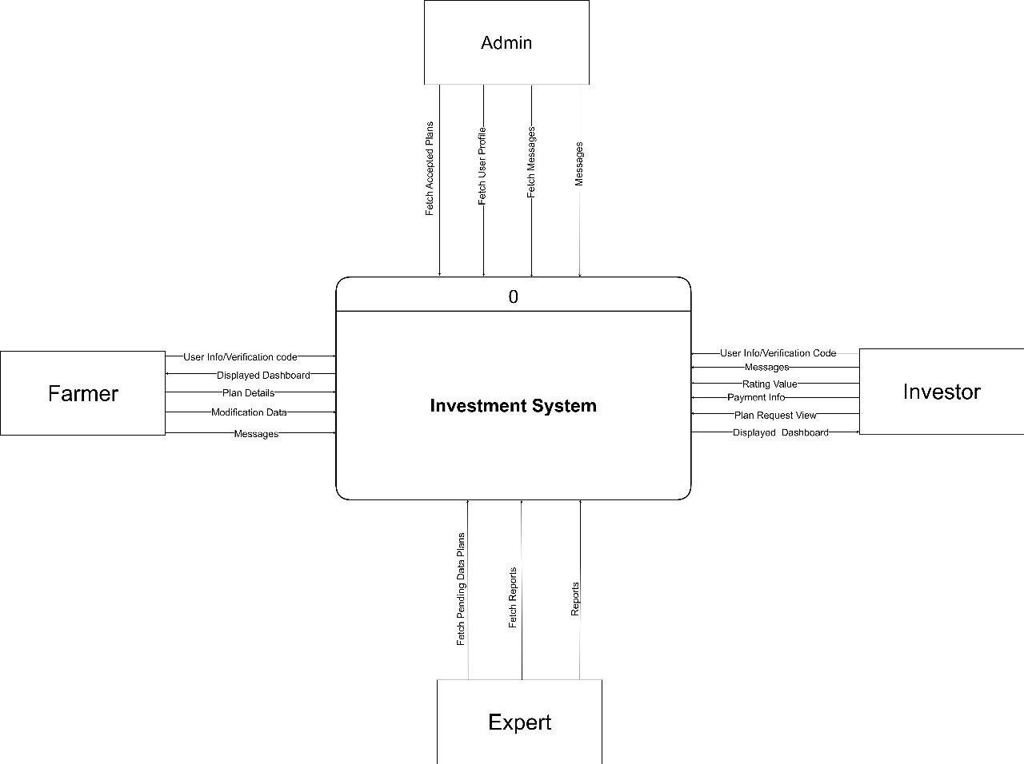

    - DATAFLOW DIAGRAM (LEVEL 1)
Investment:
Logical:
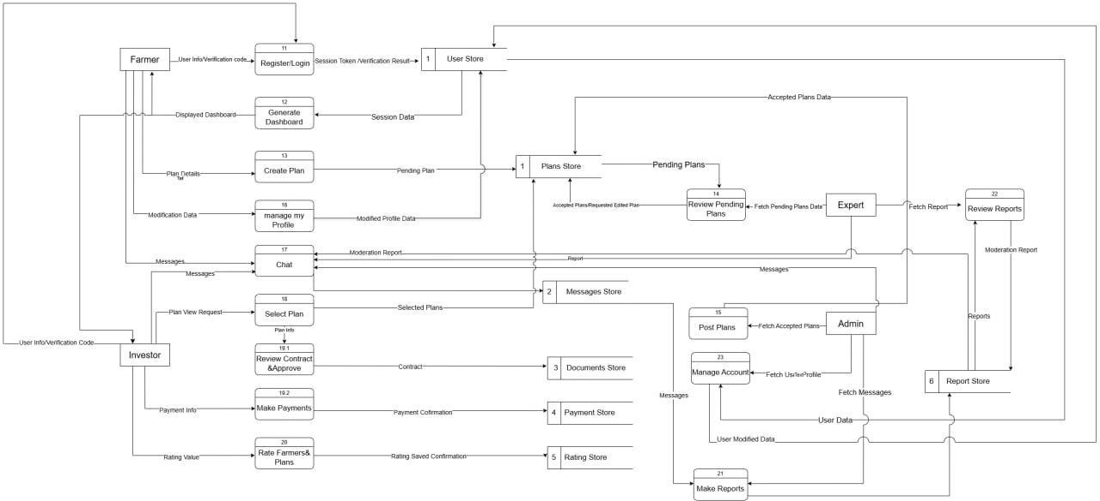

Physical:
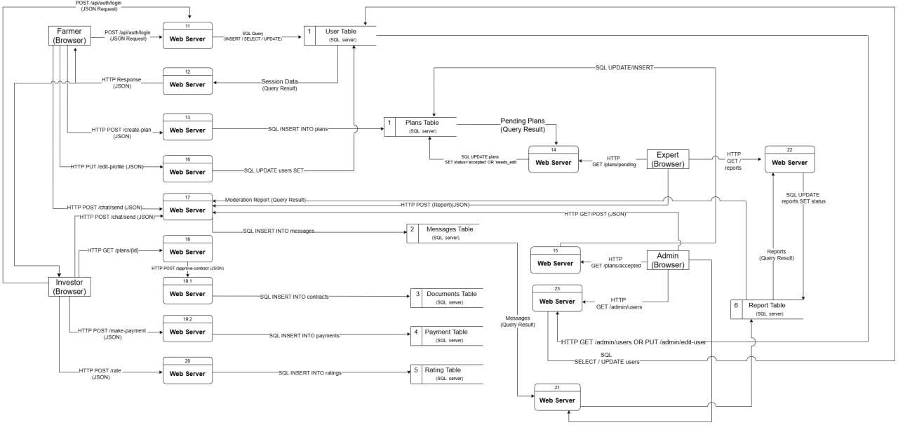

  - ACTIVITY DIAGRAM
Investment:
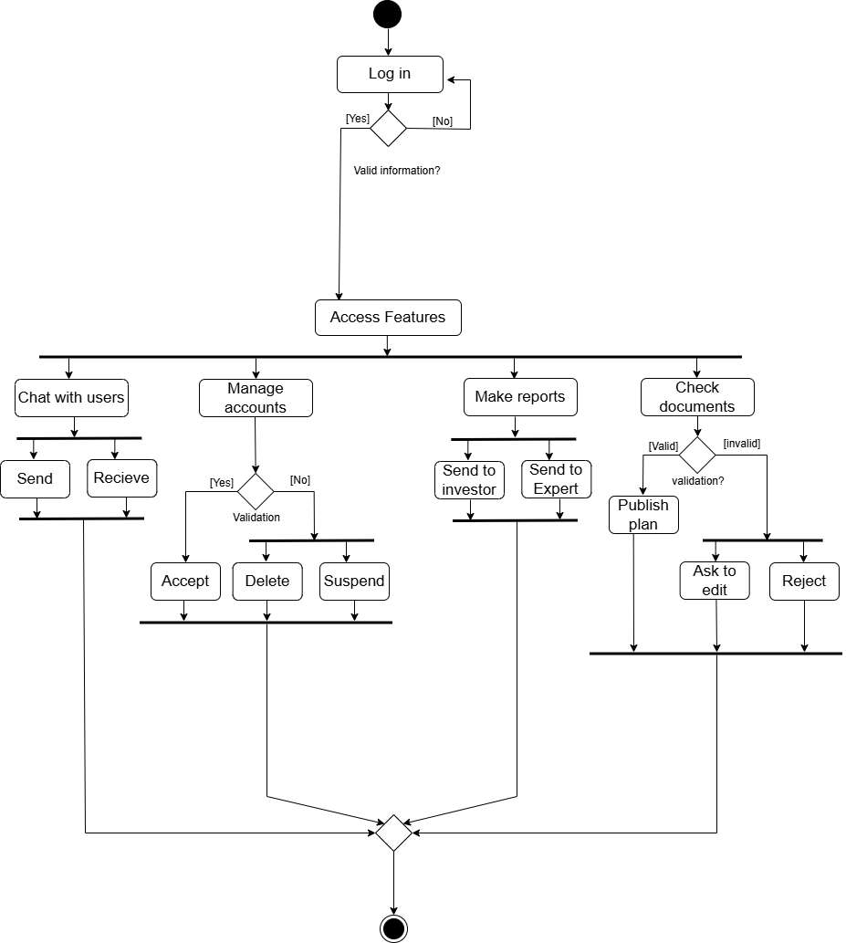
1-Admin

2-Expert Team
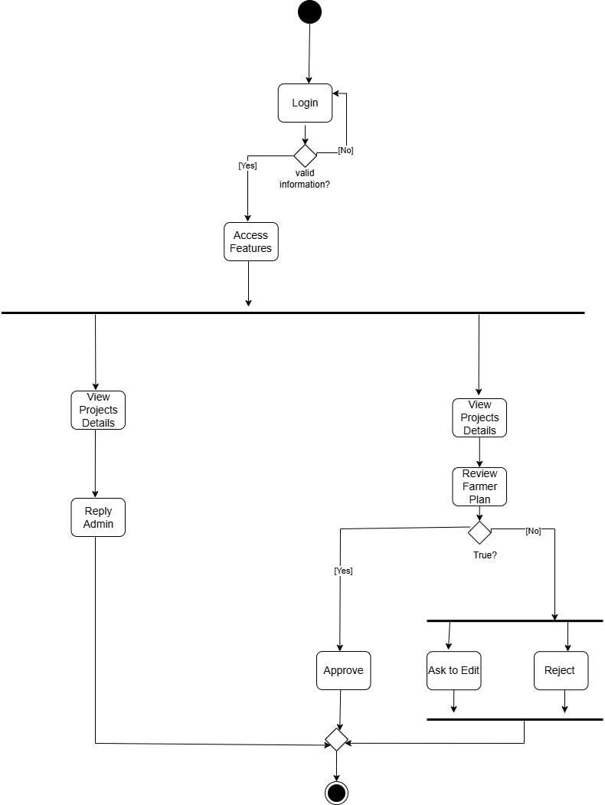
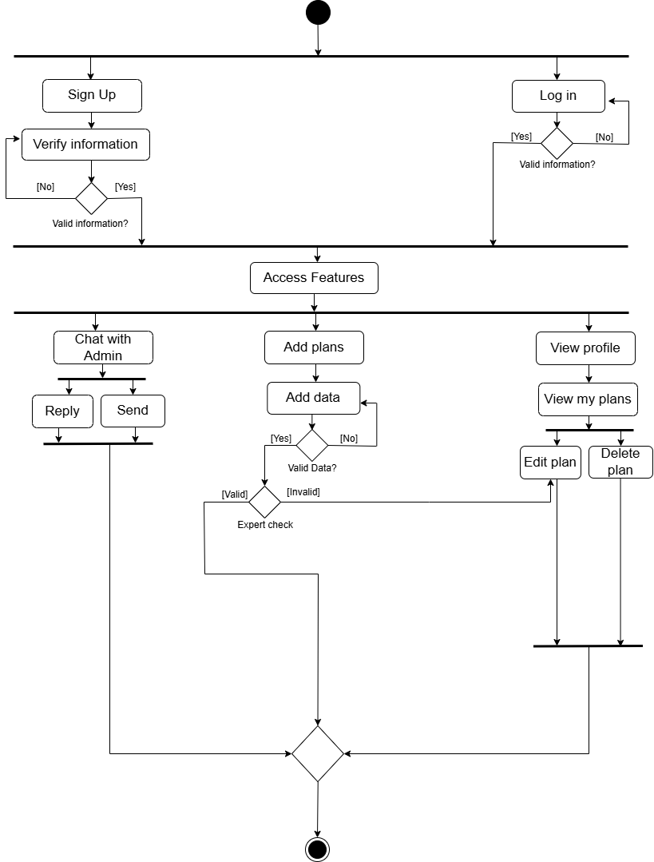
3-Farmer

4-Investor
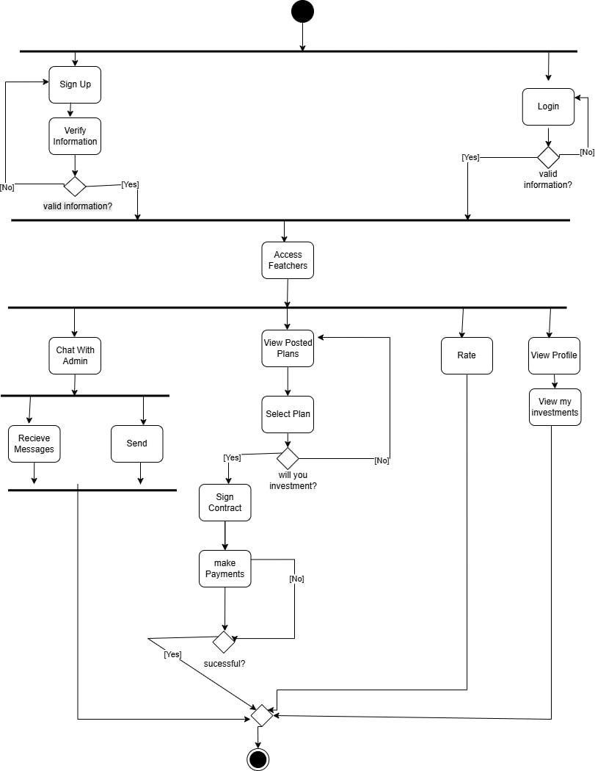

  - ER DIAGRAM
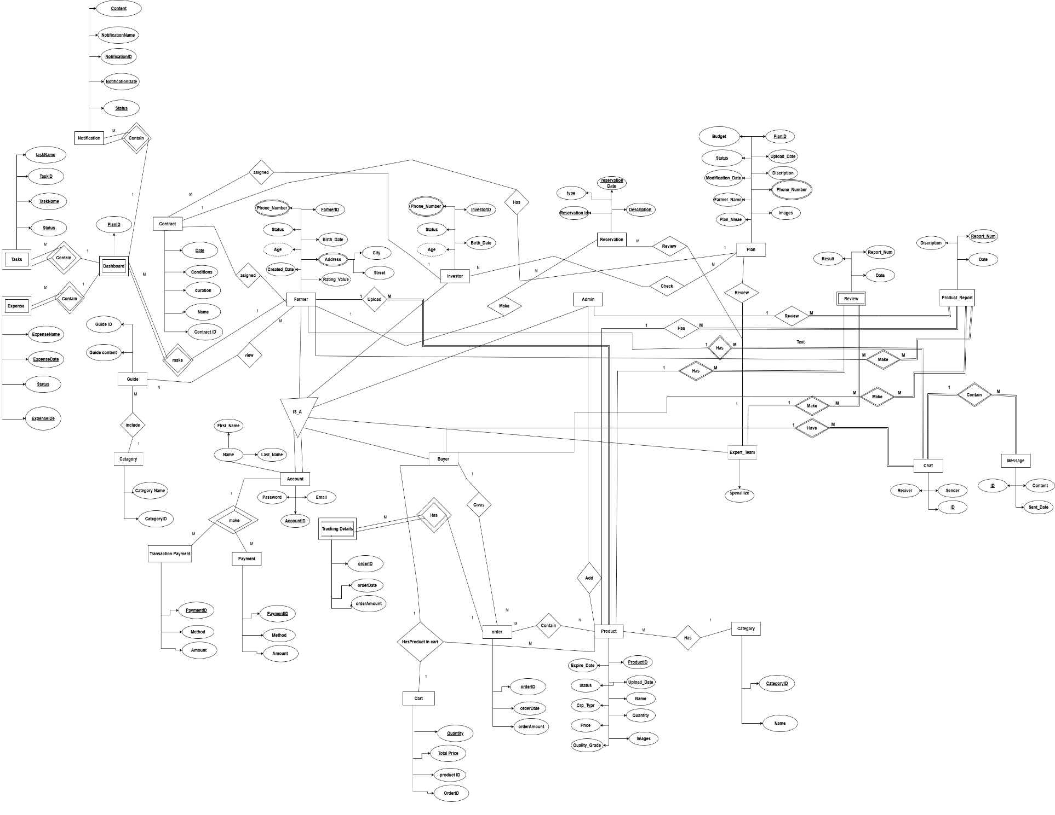
  - Class Diagram

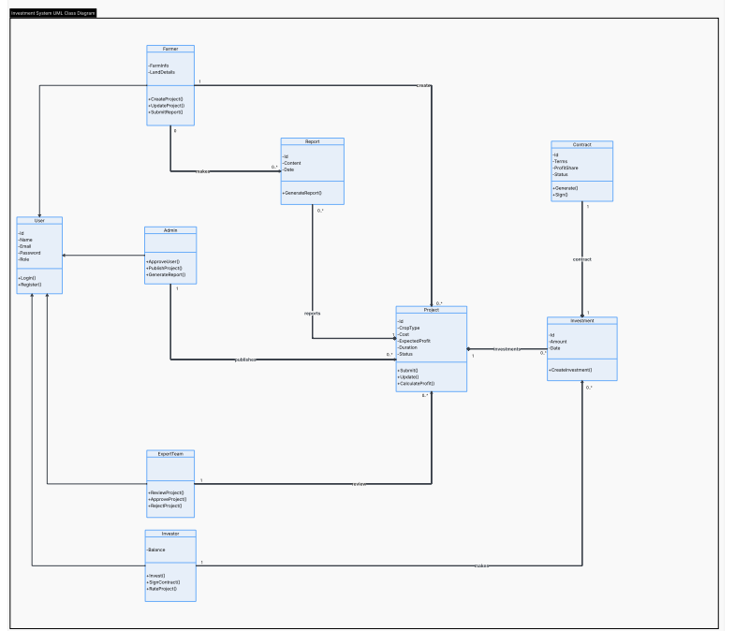

  - Sequence Diagram
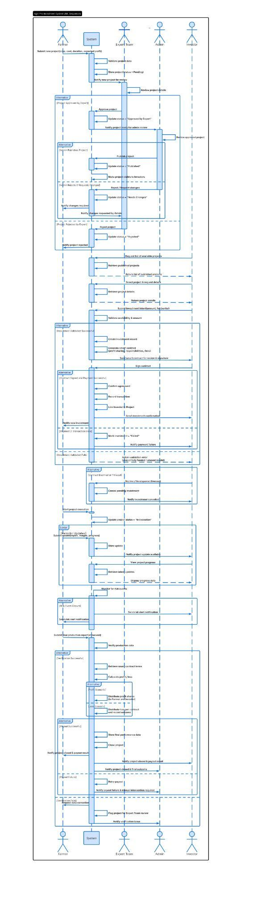

CHAPTER 5

CONCLUSIONS & FUTURE WORK
  - CONCLUSION
Agriculture represents a fundamental sector in Egypt’s economy, contributing significantly to food security, employment, and overall economic development. Despite its importance, the sector continues to face persistent challenges related to fragmented investment processes, limited transparency, insufficient access to reliable financial opportunities, and the absence of structured digital tools to support agricultural investment activities. These limitations reduce operational efficiency and increase uncertainty for stakeholders involved in the agricultural investment ecosystem.
This work introduced a digital Agricultural Investment Platform tailored to the Egyptian context, focusing on improving the investment process within the agricultural sector. The proposed system is centered on a structured investment framework that connects farmers and investors through a transparent and data-driven environment. It enables farmers to present well-defined agricultural projects, while allowing investors to access reliable project information and evaluate investment opportunities based on structured and verified data.
The platform enhances the quality of investment decision-making by improving data accessibility, standardizing project information, and reducing information asymmetry between stakeholders. This contributes to building greater trust in agricultural investment activities and reducing perceived risks associated with funding agricultural projects.
Overall, the proposed system supports the ongoing digital transformation of agricultural investment in Egypt by promoting transparency, improving efficiency, and enabling more informed investment decisions. It provides a scalable and practical approach to strengthening agricultural investment flows and contributing to the long-term sustainability and development of the sector.

  - FUTURE WORK

The following enhancements are proposed as future extensions of the system to improve scalability, intelligence, and overall efficiency:

Scalability and Performance Optimization
Enhancing the system architecture to support a larger number of users and high-volume agricultural investment data processing.

Advanced Machine Learning Models
Implementing more sophisticated predictive models to improve investment decision accuracy, risk assessment, and financial forecasting.

Offline Mode Support
Allowing limited system functionality in areas with unstable internet connectivity, with automatic data synchronization when the connection is restored.

User Behavior Analytics
Analyzing user interactions to improve usability, system personalization, and overall user experience.

Advanced Cybersecurity Mechanisms
Strengthening system security through advanced encryption techniques, intrusion detection systems, and fraud prevention mechanisms.

Integration with Governmental and Regulatory Systems
Connecting the platform with official agricultural and land databases to verify ownership, permits, and compliance data when available.

Supply Chain Expansion
Extending the system to support the agricultural supply chain, including production tracking, storage, and distribution processes.

Predictive Economic and Risk Analysis
Using historical and real-time data to predict financial risks, market trends, and investment performance fluctuations.

Simulation and Scenario Modeling
Allowing investors and stakeholders to simulate different agricultural investment scenarios before making real decisions.

Explainable Artificial Intelligence (XAI)
Providing transparent explanations for AI-based recommendations to improve trust and decision understanding.

Role-Based Access Control (RBAC)
Enhancing permission management to ensure secure and structured access for different user roles.

Geographic Information System (GIS) Integration
Visualizing agricultural lands and investment projects on interactive maps for better spatial analysis and decision-making.

Environmental Impact Assessment Tools
Evaluating the environmental sustainability and ecological impact of agricultural investment activities.

Business Intelligence and Analytics Dashboards
Providing interactive dashboards with real-time insights and key performance indicators for investment analysis.

Blockchain Integration (Future Consideration)
Introducing secure and tamper-proof transaction records to enhance transparency and trust.

Cross-Regional and Multi-Language Expansion
Supporting multiple regions, languages, and regulatory frameworks to expand the platform’s reach.

Community-Based Recommendation System
Leveraging collective user feedback and experience to improve investment and agricultural recommendations.

Farm Management Module (Future Extension)
Introducing a dedicated farm management module to support farmers in daily agricultural operations such as crop planning, resource allocation, irrigation scheduling, and performance tracking. This module would enhance operational efficiency and complement the investment decision process by providing more accurate and real-time farm-level data.

Agricultural Marketplace Module (Future Extension)
Adding an integrated agricultural marketplace that enables farmers to list and sell their harvested crops directly to buyers. This module would support product showcasing, pricing transparency, and direct communication between farmers and buyers, reducing dependency on intermediaries and improving market efficiency.

  - REFERENCES

https://www.businesstodayegypt.com/Article/1/5364/Entlaq-Launches-Egypt%E2%80%99s-1st-Agritech-Report

https://www.zawya.com/en/economy/north-africa/african-agribusiness-market-expected-to-reach-1tr-by-2030-ha77kb4y

https://data.worldbank.org/country/egypt-arab-rep

